OCTOBER IS WHITE CANE AWARENESS MONTH

The white cane is a symbol of independence and blindness. The white cane allows a legally blind person to travel independently. In 1931, the Lions Club began promoting the use of white canes for people who are blind as a national identification program.

International White Cane Day is October 15. All states and many other counties have White Cane laws, which allow pedestrians, who are legally blind, the right of way at street crossings. Most people who are legally blind have some usable vision.

- When in doubt, ask if the person needs assistance.
- Do not grab the person, cane or dog guide!
- Do not pet a dog guide. Most dog guides are working and should not be petted since it can be distracting for the dog.

Massachusetts White Cane Law states that:
All motorists, when they see a pedestrian who uses a dog guide or white cane at a street crossing, must come to a complete stop.

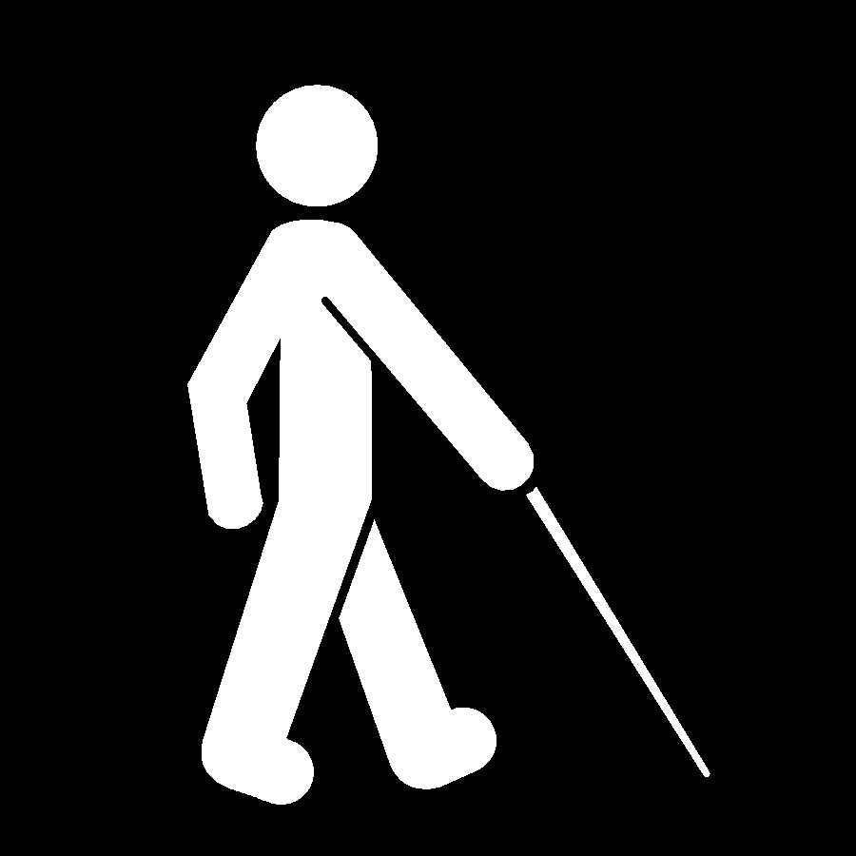

There are a variety of white canes depending on a person’s visual impairment, age, height and specific needs.

The two main types of white canes used by legally blind persons are:
- WHITE SUPPORT CANE with red at the bottom, which is designed to identify the person as legally blind but has usable travel vision and is used to assist with depth perception on stairs or curbs. And/or:
- LONG WHITE CANE with red at the bottom. This cane is for independent travel and to avoid obstacles.

Specialized training for both types of canes and travel skills are provided by a Certified Orientation and Mobility Specialist (COMS).

These canes may be rigid or collapsible. They are used to help navigate the area ahead of the user. The long cane allows a person who is blind or visually impaired to check for objects in the path of travel and changes in the walkway surface.

A small percentage of persons who are legally blind use a dog guide rather then a long cane but usually need long cane and orientation & mobility training before acceptance to a dog guide school.

Legal Blindness does not mean total blindness. Most persons who are legally blind have some usable vision. Some may be able to still read (regular or large print), recognized faces and colors (or not), depending on the type of vision impairment and degree of vision loss. Vision may also change throughout the day depending on the time of day, heath of person, lighting of area, etc.

White Cane Awareness Month is to promote better understanding of what a white cane means & how pedestrians and motorist can assist long cane users and dog guide users at street crossings.

For more information on White Cane Awareness Month or for white cane training, contact the Orientation & Mobility Department at the Mass. Commission for the Blind
800-392-6450(V/TTY) x7581.
Top Ten List of DON'Ts for Motorists when they see a
Pedestrian using a White Cane or Dog Guide at Street Crossings.
(Adapted from “The Ten List of What Motorists Shouldn’t Do When They See A Blind Person” by James Hazard & Kathy Zelaya info@oandm.org 1998)

10. Don’t stop your car more then five feet from the crosswalk line.

- Don’t yell out “it’s ok to cross”.

- Don’t get impatient when waiting for pedestrian who is visually impaired to cross. If the pedestrian places the long cane into the street, it usually indicates he or she will begin a street crossing. If the cane traveler takes a step back & pulls back the cane from the curb, it usually indicates the person will not be crossing at that time.

7. Don’t consider a ‘rolling’ stop as a complete stop. A stop sign means STOP!

- Don’t turn right on red without coming to a full stop and looking for pedestrians. The Right on Red Law requires drivers to come to a complete stop prior to making right turn.

- Don’t fail to stop for pedestrians at all crosswalks whether or not there is a traffic signal or stop sign. Come to a full stop.

4. Don’t stop your car in the middle of the crosswalk.

- Don’t pass another car, stopped, waiting for pedestrians cross the street.

- Don’t wave to pedestrians who are using a white cane or dog guide to indicate that you are waiting for them to cross. They CAN NOT see you.

- Don’t honk!

Massachusetts White Cane Law: All motorists, when they see a pedestrian who uses a dog guide or a white cane at a street crossing, must come to a complete stop.

MASSACHUSETTS WHITE CANE LAW

All motorists, when they see a pedestrian who uses a dog guide or a white cane at a street crossing, must come to a complete stop.

Massachusetts General Laws Chapter 90 Section 14A

“Whenever a totally or partially blind pedestrian, guided by a guide dog or carrying in a raised or extended position a cane or walking stick which is white in color or white tipped with red, crosses or attempts to cross a way, the driver of every vehicle approaching the place where such pedestrian is crossing or attempting to cross shall bring his vehicle to a full stop, and before proceeding shall take such precautions as may be necessary to avoid injuring such pedestrian. A person who owns an animal shall restrain and control such animal on a leash when in proximity to a guide dog that is on a public or private way. Nothing contained in this section shall be constructed to deprive any totally or partially blind person, not carrying such a cane or walking stick or not being guided by a dog, of the rights and privileges conferred by law on pedestrians crossing ways, nor shall the failure of such blind person to carry a cone or walking stick or to be guided by a guide dog while on the ways of the Commonwealth by held to constitute or be evidence of contributory negligence. Whoever violates any provisions of this section shall be punished by a fine of no less than one hundred nor more than five hundred dollars.

October Is
White Cane Awareness Month

Yield to White Cane
and
Dog Guide Users at
Street Crossings
It’s the LAW!

Massachusetts White Cane Law: General Law Chapter 90 Section 14A
For more information, contact the Massachusetts Commission for the Blind
617-727-5550/V or 800-392-6450/V-6556/TTY www.mass.gov.ma.us/mcb
Suggested Student White Cane Activities

- Research the origin of the White Cane.

- Write a letter to the local paper on White Cane Day.

- Do a presentation or project for class or school on Legal Blindness, White Cane, DeafBlindness, Braille, Helen Keller, Louis Braille, etc.

- Attend a Local Commission on Disability Meeting.

- Visit the State Commission for the Blind, School for the Blind, local blindness agency, etc.

- Do a presentation on local cable station.

- Attend a meeting of the Local Lions Club.

